65.Advanced matrix Library with complete oop

#include <iostream>
#include <vector>
#include <functional>
using namespace std;
class Matrix {
protected:
int rows, cols;
vector<vector<double>> data;
public:
Matrix(int r, int c) : rows(r), cols(c) {
data.assign(rows, vector<double>(cols, 0));
}
virtual void display() const {
cout << "Matrix (" << rows << "x" << cols << "):\n";
for (int i = 0; i < rows; i++) {
for (int j = 0; j < cols; j++)
cout << data[i][j] << " ";
cout << "\n";
}
}
virtual double determinant() const {
cout << "Determinant not defined for this matrix type.\n";
return 0;
}
virtual void apply(function<double(double)> f) {
for (int i = 0; i < rows; i++)
for (int j = 0; j < cols; j++)
data[i][j] = f(data[i][j]);
}
virtual ~Matrix() {}
};
class SquareMatrix : public Matrix {
public:
SquareMatrix(int n) : Matrix(n, n) {
// Initialize with default values
for (int i = 0; i < n; i++)
for (int j = 0; j < n; j++)
data[i][j] = (i == j) ? 1 : 0; // identity by default
}
double determinant() const override {
if (rows == 2) {
return (data[0][0] * data[1][1]) - (data[0][1] * data[1][0]);
}
if (rows == 3) {
return data[0][0]*(data[1][1]*data[2][2] - data[1][2]*data[2][1]) -
data[0][1]*(data[1][0]*data[2][2] - data[1][2]*data[2][0]) +
data[0][2]*(data[1][0]*data[2][1] - data[1][1]*data[2][0]);
}
cout << "Determinant calculation for larger size not implemented.\n";
return 0;
}
};
class IdentityMatrix : public SquareMatrix {
public:
IdentityMatrix(int n) : SquareMatrix(n) {
for (int i = 0; i < n; i++)
for (int j = 0; j < n; j++)
data[i][j] = (i == j) ? 1 : 0;
}
};
class DiagonalMatrix : public SquareMatrix {
public:
DiagonalMatrix(int n) : SquareMatrix(n) {
for (int i = 0; i < n; i++)
for (int j = 0; j < n; j++)
data[i][j] = (i == j) ? (i + 1) : 0; // diagonal = 1,2,3...
}
};
class SparseMatrix : public Matrix {
public:
SparseMatrix(int r, int c) : Matrix(r, c) {
// Fill only a few elements for demonstration
if (r > 0 && c > 0) {
data[0][0] = 5;
if (r > 1 && c > 1) data[r-1][c-1] = 10;
}
}
void display() const override {
cout << "Sparse Matrix (" << rows << "x" << cols << ") non-zero elements:\n";
for (int i = 0; i < rows; i++)
for (int j = 0; j < cols; j++)
if (data[i][j] != 0)
cout << "(" << i << "," << j << ") = " << data[i][j] << "\n";
}
};
int main() {
Matrix* matrices[3];
matrices[0] = new SquareMatrix(3);
matrices[1] = new DiagonalMatrix(3);
matrices[2] = new SparseMatrix(4, 4);
cout << "=== Matrix Demonstration ===\n";
for (int i = 0; i < 3; i++) {
matrices[i]->display();
cout << "Determinant: " << matrices[i]->determinant() << "\n\n";
}
auto doubleElements = [](double x) { return x * 2; };
SquareMatrix m(3);
cout << "Original Square Matrix:\n";
m.display();
m.apply(doubleElements);
cout << "After doubling each element:\n";
m.display();
for (int i = 0; i < 3; i++)
delete matrices[i];
return 0;
}
OUTPUT
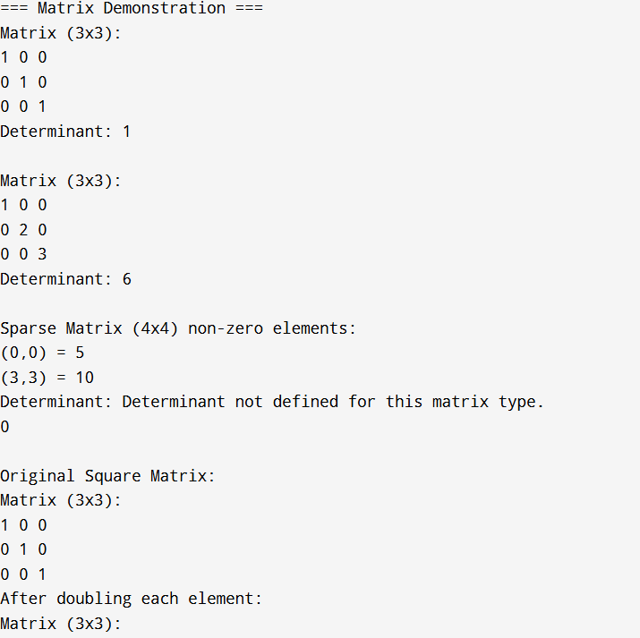
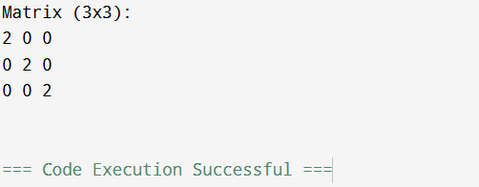
Definition:
An Advanced Matrix Library with Complete Object-Oriented Programming (OOP) refers to a software library designed to perform complex matrix operations (such as addition, multiplication, inversion, transposition, determinant calculation, etc.) using object-oriented programming principles like encapsulation, inheritance, polymorphism, and abstraction.

